**Objective:** At the end of this lab session students should be able to join tables and retrieve information.

**Table joining – part 2**

Section 1

You already know how join two or more tables when retrieving data in relational databases. Thus, in order for tables to be joined, there must be a foreign key relationship between them.

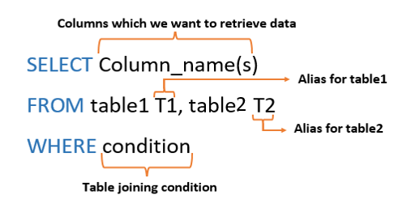

Figure 1: Table join syntax

Part a - Aliasing

Giving a temporary name (Alias) to a table or a column

Part b - Table joining condition

To join both tables the table joining condition should be written within the where clause always.

Section 2

Example

1. How many employees are there in each department, List the Department name and the no of Employees?

**Employee table**

|  |  |  |  |  |
| --- | --- | --- | --- | --- |
| **Ename** | **NIC** | **Eno** | **address** | **dnumber** |
| Smith,John B | 901250087V | 100 | 731 Fondren, Houston | 5 |
| Wrong, Franklin T. | 895290452V | 101 | 638 Voss, Houston | 5 |
| Zelaya, Alicia J. | 923859070V | 102 | 33321 Castle, Spring | 4 |

**Department table**

|  |  |
| --- | --- |
| **dno** | **dname** |
| 1 | Headquarters |
| 4 | Administration |
| 5 | Research |

# Step 01

We have to use both tables to get the required information and to get the number of employees in each department, COUNT function should be used.

**SELECT D.dname, COUNT (*) AS ‘No of employees’**

**FROM Employee E, Department D**

**WHERE E. dnumber = D. dno**

**GROUP BY D.dname,**

# Step 02

The resulting table is given in figure 2.

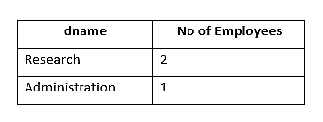

Figure 2: Output table

Exercise

1. How many Students are there in each course? List the CID and the number of students.

**SELECT CID, COUNT (SID) AS 'No of Student'**

**FROM Student**

**GROUP BY CID;**

1. How many Students are there in each course? List the course name and the number of Students.

**SELECT c.Cname, COUNT (s.SID) AS 'Stude nt Count'**

**FROM Student s, Course c**

**WHERE s.CID = C.CID**

**GROUP BY s.CID, c.Cname;**

1. What are the courses which offer more than 2 modules for year 1 students?

SELECT c.Cname, COUNT(o.Mcode) AS 'Modul Count'

FROM Course c, Offers o

WHERE c.CID=o.CID AND o.Accadamic_year ='Y1'

GROUP BY c.CID, C.Cname

HAVING COUNT(o.Mcode)>2;

1. What are the courses which offer more than 2 modules for any academic year? List the course names, academic year and the no of modules offered. Sort the result according to the no of modules.

**SELECT c.Cname, o.Accadamic_year, COUNT(o.MCode)**

**FROM Course c, Offers o**

**WHERE c.CID = o.CID**

**GROUP BY c.CID, c.Cname, o.Accadamic_year**

**HAVING COUNT(o.Mcode)>2**

**ORDER BY COUNT(o.Mcode);**